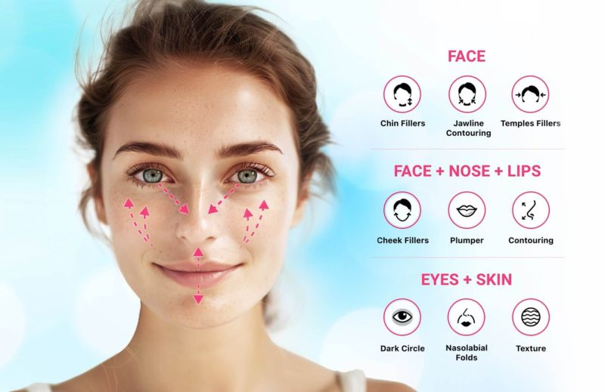

Project Objective
To develop an AI-driven system that analyzes facial features from an image, measures attributes such as eye age, skin tone, wrinkles, redness, and uniformity, and generates a detailed skin health report with grading (e.g., Poor, Average, Good).

Technologies
- Programming Language: Python
- Libraries/Frameworks:
  - Deep Learning: TensorFlow or PyTorch
  - Image Processing: OpenCV
  - Facial Analysis: Dlib, MediaPipe, or DeepFace
  - Skin Analysis: SciPy and OpenCV for skin segmentation
- Pre-trained Models:
  - Face Detection: MediaPipe Face Detection, Haar Cascades, or YOLOv8.
  - Wrinkle Detection: Pre-trained CNNs or Mask R-CNN for skin texture analysis.
  - Eye Analysis: Vision Transformers (ViT) or EfficientNet for detecting fine details like puffiness or age-related markers.
- Visualization Tools:
  - Matplotlib or Seaborn for generating the skin health report.
  - Streamlit or Flask for building an interactive user interface.
- Data Labeling Tools: LabelImg or Roboflow for custom dataset creation.

Steps to Implement

1. Data Collection
- Sources: Use publicly available skin health datasets or create your dataset by annotating features such as wrinkles, redness, skin tone, etc.
- Attributes to Collect:
  - Skin tone (light, medium, dark)
  - Wrinkle density
  - Redness level
  - Eye features (puffiness, dark circles)
  - Uniformity of skin texture

2. Preprocessing
- Face Detection: Detect and segment the face using MediaPipe or Dlib.
- Region of Interest (ROI) Extraction:
  - Extract specific areas: eyes, cheeks, forehead, etc.
  - Use facial landmarks to focus on zones like the T-zone or under-eye area.
- Data Augmentation: Apply rotation, scaling, and flipping to improve model generalization.

3. Model Selection

Facial Feature Classification
- Skin Tone: Histogram-based classifier or ResNet for classification.
- Wrinkles and Fine Lines: Mask R-CNN or a custom CNN to identify wrinkle patterns.
- Eye Features (Puffiness, Dark Circles):
  - Vision Transformers (ViT) or EfficientNet for fine-grained detection.
- Redness and Uniformity:
  - U-Net or DeepLabV3 for segmentation to detect uneven patches or redness.

Pre-trained Models for Transfer Learning
- VGG16, ResNet, or MobileNet for transfer learning on custom skin health datasets.

4. Grading System
Define grading criteria for each feature:
- Skin Tone Uniformity:
  - Good: Uniform skin tone with no visible discoloration.
  - Average: Slightly uneven tone.
  - Poor: Noticeable discoloration or patchiness.
- Wrinkles:
  - Good: Minimal wrinkle presence.
  - Average: Moderate fine lines.
  - Poor: Deep wrinkles and visible fine lines.
- Redness:
  - Good: No redness.
  - Average: Mild redness in specific areas.
  - Poor: Widespread redness.
- Eye Features:
  - Good: No dark circles or puffiness.
  - Average: Moderate puffiness or mild discoloration.
  - Poor: Severe puffiness or dark circles.
Use thresholds derived from data distribution or expert dermatology input.

5. Training and Evaluation
- Loss Function: Use binary cross-entropy for binary classification (e.g., good vs. poor) and categorical cross-entropy for multi-class grading.
- Evaluation Metrics: Accuracy, F1-Score, Precision, Recall for classification models.

6. Report Generation
Generate a skin health report with:
- Numerical scores for each feature.
- Grading (Good, Average, Poor) based on thresholds.
- Recommendations for improvement (e.g., "Use sunscreen to reduce redness").

7. Deployment
- Interactive Web Application:
  - Use Streamlit for a user-friendly interface.
  - Users can upload an image, and the app will display the extracted features, grades, and recommendations.
- Cloud Hosting: Deploy the app using AWS, Azure, or Google Cloud.

Workflow
- Upload image → Preprocess (face detection, feature segmentation) → Apply models for feature extraction → Generate scores → Map scores to grades → Visualize the report.

Challenges and Solutions
- Low-quality images:
  - Use high-resolution datasets and noise reduction techniques.
- Data imbalance:
  - Oversample minority classes or use weighted loss functions.
- Fine-grained feature detection:
  - Use high-capacity models like Vision Transformers or ensemble models.

Expected Outcome
- A system that generates a skin health report, categorizes features into grades (Poor, Average, Good), and provides actionable insights for improvement.

